**Software Requirements Specifications (SRS)**

**ERP Solution for Lakhsma Sweater Ltd.**

REFERENCE: GW/ERP/SRS/

**Version: 1.1**

**Date of Release: October 11, 2015**



**Genweb2 Limited**

TK Bhaban (11th Floor),

13 Kazi Nazrul Islam Avenue,

Kawran Bazar, Dhaka 1215, Bangladesh

web: [http://www.genweb2.com](http://www.genweb2.com/)

**Contents**

Document Release History 4

1.0 Introduction 5

1.1 Purpose of SRS 5

2.0 Procurement 6

2.1 Overview 6

2.2 Functional features of Merchandiser modules are given below (actor wise) 6

2.3 Procurement Process flow 7

2.4 User Class 7

3.0 Process Flow: 8

3.1 Raise purchase requisition 8

3.2 Quotation Selection Process: 9

3.3 Issue purchase order 10

4.0 USE CASE Diagram 12

4.1 Purchase Requisition Process 12

4.2 Price Quotation Receive & Selection Process: 12

4.3 Purchase Order Issue Process: 13

5.0 USE CASE Details 14

5.1 UC/Pro/001/ Raise Purchase Requisition 14

5.2 UC/Pro/002/ Edit/Modify Purchase requisition 15

5.3 UC/Pro/003/ Approve Purchase Requisition 16

5.4 UC/Pro/004/ Cancel Purchase requisition 17

5.5 UC/Pro/005/ Close Purchase requisition 18

5.6 UC/Pro/006/ Receive Quotation 19

5.7 UC/Pro/007/ Edit/Modify Quotation 20

5.8 UC/Pro/008/ Select Quotation 21

5.9 UC/Pro/009/ Cancel Quotation 22

5.10 UC/Pro/010/ Issue Purchase Order 23

5.11 UC/Pro/011/ Edit/Modify Purchase Order 25

5.12 UC/Pro/012/ Approve Purchase Order Level_1 26

5.13 UC/Pro/013/ Approve Purchase Order Level_2 27

5.14 UC/Pro/014/ Cancel Purchase order 28

6.0 Procurement mock-up 30

6.1 Purchase Order 30

6.2 Purchase Requisition 31

6.3 Receive Quotation 31

Document Release History

| Sl. No. | Version Number | Release Date | Prepared By | Reviewed By | Approved By | Reasons for New Release |
| --- | --- | --- | --- | --- | --- | --- |
| 1 | 1.0 | 5th Oct, 2015 | Nazifa Chowdhury |  | N/A |  |
| 1 | 1.1 | 7th Oct, 2015 | Nazifa Chowdhury |  |  | Use case table update, add mock up and process flow image |

# Introduction

## Purpose of SRS

The purposes of this SRS are to clearly identify the customer requirements and provide a detailed document. The customer will review the document and approve/make change as required. It will also help the review team to be able to validate whether the customer requirements has been fulfilled.

The SRS will also help the Analyst and Designer to understand and track the Requirements for the proposed system. It will also identify a set of requirements for the Development of the project. The SRS helps to describe the behavior of the system to be developed.

# Procurement

## Overview

Procurement is the act of acquiring, buying goods, services or works from an external source. It is favorable that the goods, services or works are appropriate and that they are procured at the best possible cost to meet the needs of the acquirer in terms of quality and quantity, time, and location.

## Functional features of Merchandiser modules are given below (actor wise)

* Employee/Department/Production floor raises indent
* Store keeper raises purchase requisition
* --Approval authority check purchase requisition if they do not approve then purchase requisition will be cancel
* When approval authority approve purchase requisition then procurement executive send request to supplier(s) for quotation
* Procurement executive get quotation from several supplier
* Procurement executive request procurement manager to select the quotation
* If procurement manager do not select any quotation then the quotation will be cancel
* If procurement manager select the quotation then procurement executive creates purchase order
* Procurement executive issue purchase order and send purchase order to procurement manager
* If procurement manager not approve purchase order then purchase order will be cancel
* If procurement manager approve the purchase order then he send request to management for approving purchase order
* If management do not approve then purchase order will be cancel
* If management approve purchase order then procurement manager get acknowledgement from management
* Procurement executive get acknowledgement from procurement manager
* Purchase order sent to supplier

## Procurement Process flow

* Raise purchase requisition
* Receive Quotation
* Issue purchase order

## User Class

|  |  |  |
| --- | --- | --- |
| User Class/ Actor | Characteristics | Responsibilities |
| Procurement user | * Raise purchase requisition * Create purchase order | * Add/modify requisition |
| Procurement manager | * Approve/Cancel purchase requisition and purchase order | * Add/modify purchase order * Approve/Cancel purchase order |
| Management | * Approve/Cancel purchase order | * Approve/Cancel purchase order |

# Process Flow:

## Raise purchase requisition

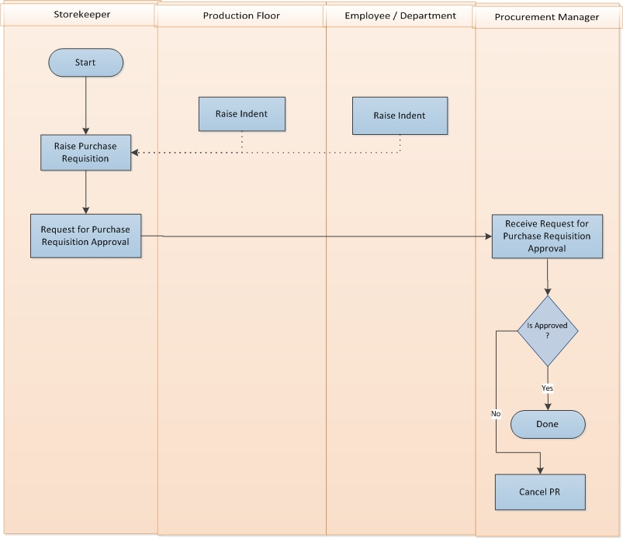

Fig: Raise purchase requisition

Raise purchase requisition details:

* Production Floor or Employee/Department raise Indent for specific item to Store Keeper.
* Store Keeper receives Purchase Requisition and takes necessary steps to process the request.
* After verifying Request for Purchase store keeper sends the request to Approval Authority for approval.
  + If requisition contains valid information, then Approval Authority approves the requisition.
  + Otherwise Approval Authority rejects the request.

## Quotation Selection Process:

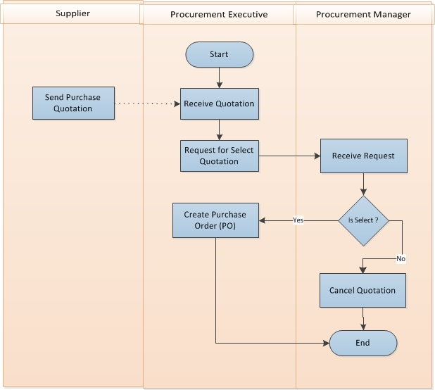

Fig: Quotation Selection Process

Receive Quotation details

* Procurement Executive receives Quotation which was send by supplier with details specification of materials/products.
* Procurement Executive request to Procurement Manager for Request for Select Quotation depending on receives purchased requisition.
* Procurement Manager receives the Request and takes necessary decision
  + If select: If Procurement Manager select the quotation, then sent a selection confirmation message for taking necessary steps
  + If rejected: If Procurement Manager rejects the quotation, then process will stop.
* After getting Selection confirmation message from Procurement Manager, Procurement Executive creates Purchase Order (PO).

## Issue purchase order

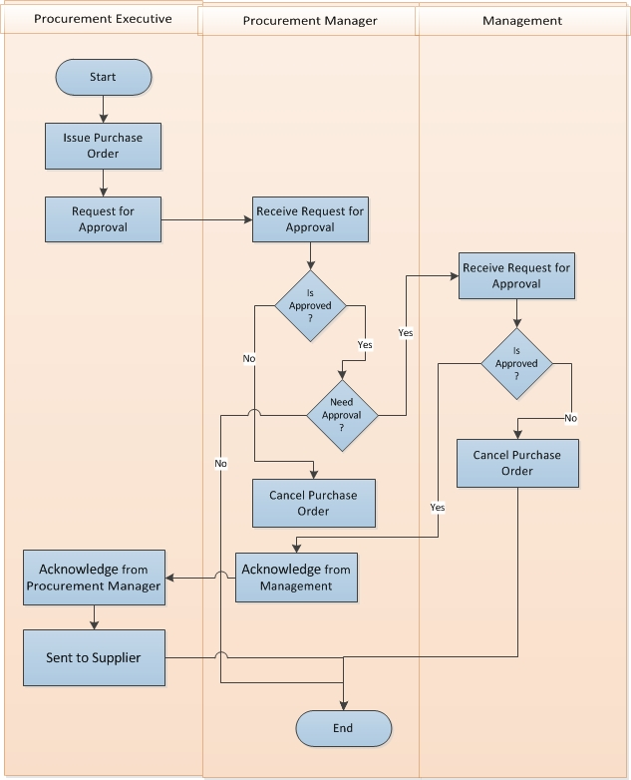

Fig: Issue purchase order

Issue purchase order details

* Procurement Executive issue purchase order
* Procurement Executive send request to Procurement Manager for Purchase Order Approval
* Procurement Manager receive Purchase Order from Procurement Executive
* If Procurement Manager is approve then sent request to Management for Purchase Order Approval
* If Procurement Manager is not approve then cancel the Purchase Order
* Management receive Purchase Order from Procurement Manager
* If Management is approve then back to Procurement Manager.
* Procurement Manager receives approval from Management and acknowledge to Procurement Executive.
* Procurement Executive sent Approval Purchase Order to Supplier
* If Management is not approve then cancel the Purchase Order

# USE CASE Diagram

## Purchase Requisition Process

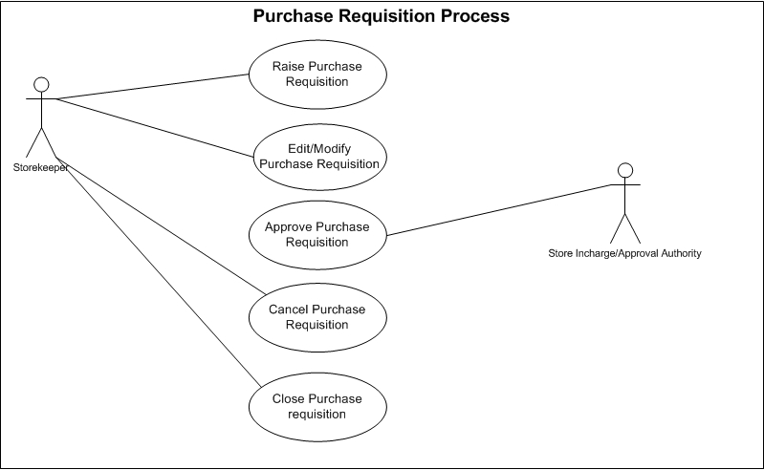

Fig: Purchase Requisition Process

## Price Quotation Receive & Selection Process:

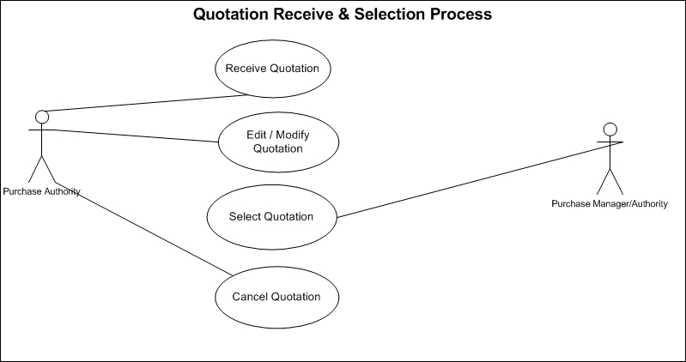

Fig: Price Quotation Receive & Selection Process

## Purchase Order Issue Process:

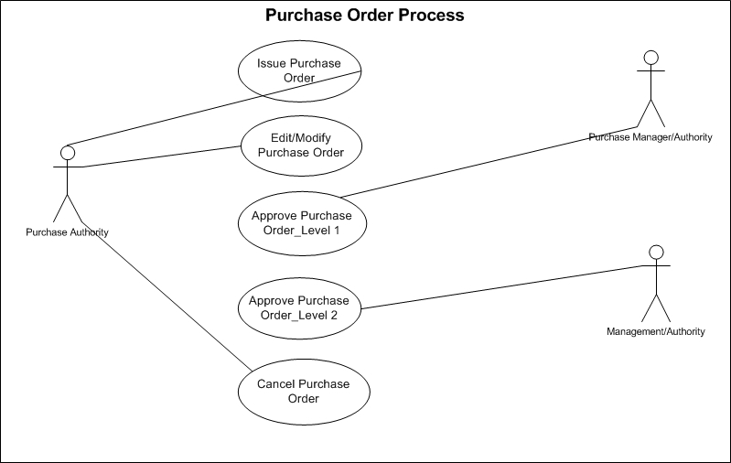

Fig: Purchase Order Issue Process

# USE CASE Details

## UC/Pro/001/ Raise Purchase Requisition

|  |  |  |
| --- | --- | --- |
| Use Case ID: UC/PRO/001 | | |
| Use Case Name**: Raise Purchase Requisition** | | |
| Created By: **GenWeb2 Ltd.** | | Date Created: 11 October, 2015 |
| Actors: | * Store Authority | |
| Trigger: | * When Store Authority needs to raise Purchase Requisition | |
| Business Rule | * Purchase Requisition can be raised against Indent * Purchase Requisition can be raised Independently * Bill of Materials (BOM) will act as Requisition so Purchase Requisition can’t be generated against Bill of Materials (BOM). * Multiple Items can exist in single Purchase Requisition. * Item(s) Number & Quantity can be manipulated in Purchase Requisition against single or multiple Indents. * Price/Rate may or may not be declared in Purchase Requisition * Only Approved Purchase Requisition will be available for creating Purchase Order. | |
| Description: | If inventory needs to purchase any item against any Indent (from production floor or employee) or independently then Inventory Authority raise a purchase Requisition to Procurement Department for Source those items. | |
| Frequency of Use | * Medium (Regularly) | |
| Preconditions | * Item (s) must be exists in System. * Indent creation (If Purchase Requisition is against Indent). * Unit of Measurement must exist in System. * Currency needs to exist in System. | |
| Post Conditions | * Appropriate message will be displayed after each entry being saved / updated. * Approval Authority will be notified for approval response. * Purchase Requisition’s Item (s) & quantity will be deducted from balance in Indent (If Purchase Requisition is against Indent). * If Purchase Requisition is against Indent then Balance (Purchase Requisition Quantity-Indent Quantity) quantity will be populated if next time Purchase Requisition trigger against that Indent. | |
| Assumption | * N/A | |
| Goal | Create Purchase Requisition in System | |
| Normal Flow | 1. Inventory will be notified after approval of any Indent. 2. Inventory raises Purchase Requisition against Indent. 3. Approval Authority approves the Purchase Requisition. | |
| Alternate Flow | 1. Inventory will be notified if any Item stock is below reorder level 2. Purchase Requisition can be raised independently 3. Inventory Authority can raise Purchase Requisition if any item stock is under reorder level | |
| Exception | * Proper message should be displayed if Purchase Requisition can’t be saved. * Proper message should be displayed if any master or dependent data is missing or not found. * Appropriate message should be displayed if mandatory fields are not filled. * Any system exception/Application exception should be handled centrally with proper user message during the page browse/save/update/view operations. | |
| Cross Reference | * N/A | |

## UC/Pro/002/ Edit/Modify Purchase requisition

|  |  |  |
| --- | --- | --- |
| Use Case ID: UC/PRO/002 | | |
| Use Case Name**: Edit/Modify Purchase Requisition** | | |
| Created By: **GenWeb2 Ltd.** | | Date Created: 11 October, 2015 |
| Actors: | * Store Authority | |
| Trigger: | * When any modification requires for any unapproved Purchase Requisition. | |
| Business Rule | * If Purchase Requisition is not approved then Edit/Modification can take place. * Modification after approval needs special permission. * Modification can take place if there are any mistakes in Purchase Requisition. * Modification can take place if there are any changes in Purchase Requisition. * Modification can take place if there is any changes in related Indent level | |
| Description: | If changes or modification requires for any raised and unapproved Purchase Requisition then store authority edit/modify that Purchase Requisition. | |
| Frequency of Use | * Medium | |
| Preconditions | * Purchase Requisition Must exists in System. * Modification in Indent which has been used in Purchase Requisition. * Purchase Requisition status must be “active”. * Purchase Requisition must be at unapproved state. | |
| Post Conditions | * Appropriate message will be displayed after each entry being saved/updated. * Approval Authority will be notified for approval response. * Purchase Requisition’s Item (s) & quantity will be deducted from balance in Indent (If Purchase Requisition is against Indent). * If Purchase Requisition was created against Indent then Balance (Purchase Requisition Quantity-Indent Quantity) quantity will be populated as balance while raising the next Purchase Requisition against the same Indent. | |
| Assumption | * N/A | |
| Goal | Adjust necessary changes Purchase Requisition | |
| Normal Flow | 1. Authorized user can edit/modify unapproved Purchase Requisitions. 2. If Indent got modified then authorized person get notification for raised Purchase Order against Indent. 3. Authorized user can login to system and open the Purchase Requisition needs to modify. 4. Authorized user can modify the Purchase Requisition which has been created independently. 5. User can edit/modify rate/Price. 6. User can edit/modify Item (s) & Quantity. | |
| Alternate Flow | * Approved Purchase Requisition get special permission to modify by the Authorized user. * Authorized users edit/modify respective require modifications. | |
| Exception | * Proper message should be displayed if no content is found while loading the project list. * Appropriate message should be displayed if mandatory fields are not filled. * Any system exception/application exception should be handled centrally with proper user message during the page browse/save/update/view operations. | |
| Cross Reference | * Use Case ID: UC/PRO/001 | |

## UC/Pro/003/ Approve Purchase Requisition

|  |  |  |
| --- | --- | --- |
| Use Case ID: UC/PRO/003 | | |
| Use Case Name**: Approve Purchase Requisition** | | |
| Created By: **GenWeb2 Ltd.** | | Date Created: 11 October, 2015 |
| Actors: | * Store Manager | |
| Trigger: | * When any raised Purchase Requisition needs approval for further action | |
| Business Rule | * Approval Authority gets notification for pending approval Purchase Requisition(s). * Approval Authority approve the Purchase Requisition to enable it for further business action * Approval Authority reject the Purchase Requisition to cancel it for any further business action | |
| Description: | After raising Purchase Requisition by the store authority it needs to be approved by the Store manager for further approval | |
| Frequency of Use | * Medium | |
| Pre-conditions | * Purchase Requisition must exist in System. * Approval Authority got notification for pending approval request. | |
| Post Conditions | * Purchase Requisition will be approved. * Approved Purchase Requisition will be freeze for any further modification. * Approved Purchase Requisition will be available to create Purchase Order. | |
| Assumption | * N/A | |
| Goal | Approve Purchase Requisition for further use. | |
| Normal Flow | 1. Store Authority raise Purchase Requisition. 2. Approval Authority gets notification for pending approval. 3. Approval Authority Approve the Purchase Requisition. 4. Approval Authority reject the Purchase Requisition. 5. Approved Purchase Requisition can’t be modified. | |
| Alternate Flow | 1. Store Authority raise Purchase Requisition. 2. Defined approval authority other than Store Manager can approve the Purchase Requisition. 3. 2nd layer approval may require. | |
| Exception | * Proper message should be displayed if no content is found while loading the Purchase Requisition. * Appropriate message should be displayed if approval not possible. * Any system exception/application exception should be handled centrally with proper user message during the page browse/save/update/view operations. | |
| Cross Reference | * Use Case ID: UC/PRO/001 | |

## UC/Pro/004/ Cancel Purchase requisition

|  |  |  |
| --- | --- | --- |
| Use Case ID: UC/PRO/004 | | |
| Use Case Name**: Cancel Purchase Requisition** | | |
| Created By: **GenWeb2 Ltd.** | | Date Created: 11 October, 2015 |
| Actors: | * Store Manager or Authorized Store Authority | |
| Trigger: | * When any Purchase Requisition get cancelled by the authority(Approved & Unapproved both) | |
| Business Rule | * Authorized user created Purchase Requisition * Purchase Requisition may or may not be approved * Purchase Requisition can be cancelled if it is no more require. * Dependent Indent may not require any more so the Purchase Requisition may get cancelled * Requirement can get changed and will be rescheduled later on in that case Purchase Requisition may get cancelled. * If the Purchase Requisition was created against Indent then the Indent Item along with quantity will be available for creating another Purchase Requisition if Indent is not cancelled. | |
| Description: | If any Purchase Requisition get Invalid then the authority cancel that Purchase Requisition | |
| Frequency of Use | * Low | |
| Pre-conditions | * Purchase Requisition must exist. * No Purchase Order has created against the Purchase Requisition. * Entire Purchase Requisition quantity is pending yet to create Purchase Order. * Only Authorized authority can cancel Purchase Requisition. | |
| Post conditions | * Purchase Requisition will be cancelled. * No further business action will take place after cancellation of Purchase Requisition. * Purchase Requisition will not be available to create Purchase Order. * If the Purchase Requisition was created against Indent then the Indent Item along with quantity will be available for creating another Purchase Requisition if Indent is not cancelled. | |
| Assumption | * N/A | |
| Goal | Cancel any Purchase Requisition | |
| Normal Flow | 1. Store Authority raise Purchase Requisition. 2. Authorized person can cancel the Purchase Requisition. 3. Authorized user gets notification for Indent Cancellation. 4. Authorized person can Cancel Purchase Requisition if Indent is also cancelled and Purchase Order was not generated yet. 5. Store Authority Cancel the Purchase Requisition (Approved & unapproved both). | |
| Alternate Flow | * N/A | |
| Exception | * Proper message should be displayed if no content is found while loading the Purchase Requisition. * Appropriate message should be displayed if Purchase Requisition Cancellation not possible. * Any system exception/application exception should be handled centrally with proper user message during the page browse/save/update/view operations. | |
| Cross Reference | * Use Case ID: UC/PRO/001 | |

## UC/Pro/005/ Close Purchase requisition

|  |  |  |
| --- | --- | --- |
| Use Case ID: Pro/UC/005 | | |
| Use Case Name**: Close Purchase requisition** | | |
| Created By: **GenWeb2 Ltd.** | | Date Created: 11 October, 2015 |
| Actors: | * Store Manager or Authorized Store Authority. | |
| Trigger: | * When Store Authority wants to close any Purchase Requisition | |
| Business Rule | * Authorized user created Purchase Requisition. * Purchase Requisition is already approved. * Purchase Requisition cannot be cancelled. * Purchase Order has already been generated against the Purchase Order (Partially). * No Purchase Order will be created against the Purchase Requisition for pending Items(Ex: Purchase Requisition is having 100 quantity and Purchase Order was created for 400 quantity and somehow it has been decided that no Purchase Order will be generated for the balance 600 qty. In that case Purchase Requisition can’t be cancelled as already valid Purchase Order exists against it, On the other side it can’t display 600 quantity as balance for yet to create Purchase Order so Close statement of any Purchase Requisition will keep the Existing Purchase Order active and no Purchase Requisition quantity will be displayed as pending). | |
| Description: | If any Purchase Requisition have some pending Quantity to issue Purchase Order but decision has taken that it will not be executed anymore in that case the Purchase Requisition will be cancelled so that it will not display the pending item requisition quantity for raising Purchase Order anymore. | |
| Frequency of Use | * Low | |
| Preconditions | * Purchase Requisition must exist. * Purchase Requisition was approved. * Purchase Order has created against Purchase Requisition for partial quantity. * Pending Purchase Requisition quantity must exist to create Purchase Order. | |
| Post conditions | * Purchase Requisition will be state as closed. * Already created Purchase Orders will remain same. * New Purchase Order can’t be created against that Purchase Requisition. | |
| Assumption | * N/A | |
| Goal | Close any Purchase Requisition. | |
| Normal Flow | 1. Store Authority raise Purchase Requisition. 2. Store Manager/Authority approve the Purchase Requisition. 3. Procurement Authority Issue Purchase Order (Partial). 4. Authority got decided that no further Purchase Order will be created against the pending quantity of the Purchase Requisition. 5. Close Purchase Requisition. 6. Purchase Requisition will not be available for create Purchase Order for pending quantity. | |
| Alternate Flow | * N/A | |
| Exception | * Proper message should be displayed if no content is found while loading the Purchase Requisition. * Appropriate message should be displayed if Purchase Requisition Closing not possible. * Any system exception/Application exception should be handled centrally with proper user message during the page browse/save/update/view operations. | |
| Cross Reference | * Use Case ID: UC/PRO/001 | |

## UC/Pro/006/ Receive Quotation

|  |  |  |
| --- | --- | --- |
| Use Case ID: UC/PRO/006 | | |
| Use Case Name**: Receive Quotation** | | |
| Created By: **GenWeb2 Ltd.** | | Date Created: 11 October, 2015 |
| Actors: | * Procurement Authority. | |
| Trigger: | * When Store Authority receives any quotation from Supplier | |
| Business Rule | * Purchase Authority requests for Quotation to various suppliers for requires items. * Purchase Authority receives quotations from various suppliers for requires items. * Purchase Authority makes the selection from the received quotations to issue Purchase Order. | |
| Description: | Purchase Authority ask price quotation from various supplier, Suppliers send price quotation of those asking products, Purchase Authority receive & enter those price quotation to system for further selection. | |
| Frequency of Use | * Medium | |
| Pre-conditions | * Supplier (s) name must exist in System. * Item (s) must exist in System. * Currency must exist in System. * Delivery terms must exist in System. | |
| Post Conditions | * System will have Quotation details record. * Quotations will be available for selection process. | |
| Assumption | * N/A | |
| Goal | Enter Price Quotations from Supplier in System for further use | |
| Normal Flow | 1. Purchase Authority receive price Quotation from Suppliers. 2. Purchase Authority enters quotation details to System. | |
| Alternate Flow | * N/A | |
| Exception | * Proper message should be displayed if any dependent data missing for entering Receive Quotation data. * Appropriate message should be displayed if saving not possible. * Any system exception/application exception should be handled centrally with proper user message during the page browse/save/update/view operations. | |
| Cross Reference | * N/A | |

## UC/Pro/007/ Edit/Modify Quotation

|  |  |  |
| --- | --- | --- |
| Use Case ID: UC/PRO/007 | | |
| Use Case Name**: Edit/Modify Quotation** | | |
| Created By: **GenWeb2 Ltd.** | | Date Created: 11 October, 2015 |
| Actors: | * Procurement Authority | |
| Trigger: | * When Supplier revise any price quotation. | |
| Business Rule | * Purchase authority received the quotation form Supplier. * Changes/Modifications/Revision has taken place in the quotation. * Purchase authority updates/modify the quotation accordingly. | |
| Description: | If Supplier revise the price Quotation based on negotiation or some other reason that revision needs to be incorporated in system. | |
| Frequency of Use | * Medium | |
| Pre-conditions | * Receive Quotation must exists. | |
| Post Conditions | * Appropriate message will be displayed after each entry being saved /updated. | |
| Assumption | * N/A | |
| Goal | Update the Price Quotation in System | |
| Normal Flow | 1. Purchase Authority Receive price Quotation from Suppliers. 2. Supplier revised the quotation and Purchase Authority modifies and updates the quotation accordingly. | |
| Alternate Flow | * N/A | |
| Exception | * Proper message should be displayed if no content is found while loading the Quotation Details. * Appropriate message should be displayed if edit/modification not possible. * Any system exception/Application exception should be handled centrally with proper user message during the page browse/save/update/view operations. | |
| Cross Reference | * Use Case ID: UC/PRO/006 | |

## UC/Pro/008/ Select Quotation

|  |  |  |
| --- | --- | --- |
| Use Case ID: UC/PRO/008 | | |
| Use Case Name**: Select Quotation** | | |
| Created By: **GenWeb2 Ltd.** | | Date Created: 11 October, 2015 |
| Actors: | * Procurement Manager | |
| Trigger: | * When Purchase manager select/finalize any Quotation | |
| Business Rule | * Purchase Authority receives Price Quotation from various Suppliers. * Purchase Authority selects the Quotation among the received quotations. | |
| Description: | When Purchase manager select/finalize any Quotation from Supplier for issuing Purchase Order against that quotation. | |
| Frequency of Use | * Medium | |
| Pre-conditions | * Receive Quotation must exists in System. | |
| Post conditions | * Quotation will be selected for further Business Action. * Purchase Order can be created against the selected Quotation. | |
| Assumption | * N/A | |
| Goal | Issue Purchase Order to Supplier in System | |
| Normal Flow | 1. Purchase Authority receives price Quotation from Suppliers. 2. Purchase Manager selects Quotation. 3. Purchase authority issue Purchase Order by using the selected Price Quotation. | |
| Alternate Flow | * N/A | |
| Exception | * Proper message should be displayed if no content is found while loading the Quotation Details. * Appropriate message should be displayed if quotation selection not possible. * Any system exception/application exception should be handled centrally with proper user message during the page browse/save/update/view operations. | |
| Cross Reference | * Use Case ID: UC/PRO/006 | |

## UC/Pro/009/ Cancel Quotation

|  |  |  |
| --- | --- | --- |
| Use Case ID: UC/PRO/009 | | |
| Use Case Name**: Cancel Quotation** | | |
| Created By: **GenWeb2 Ltd.** | | Date Created: 11 October, 2015 |
| Actors: | * Procurement Manager or Nominated Procurement Authority | |
| Trigger: | * When authorized Procurement authority wants to Cancel any Quotation | |
| Business Rule | * Received or selected quotation may use in further business. * If any Quotation is declared as cancel then it will not be able to be used in any further business. * Both Unselected and Selected Quotation can be declared as ‘Cancel’. | |
| Description: | If any Quotation get Invalid for any further usages then the authorized person cancel that Quotation to prevent any further use of it. | |
| Frequency of Use | * Low | |
| Pre-conditions | * Receive Quotation must be exists in system. * Only the authorized users can have the permission to cancel any Quotation. | |
| Post Conditions | * Appropriate message will be displayed after successfully declared as cancel * This Cancelled quotation will not be available in any further downstream business flow. | |
| Assumption | * N/A | |
| Goal | Cancel any Quotation for prevent any further usages | |
| Normal Flow | 1. Purchase Authority Receive price Quotation from Suppliers 2. Price Quotation got invalid 3. Authorized Procurement person Cancel the Quotation. | |
| Alternate Flow | * N/A | |
| Exception | * Proper message should be displayed if no content is found while loading the Quotation Details. * Appropriate message should be displayed if Quotation Cancellation not possible. * Any system exception/application exception should be handled centrally with proper user message during the page browse/save/update/view operations. | |
| Cross Reference | * Use Case ID: UC/PRO/006 | |

## UC/Pro/010/ Issue Purchase Order

|  |  |  |
| --- | --- | --- |
| Use Case ID: UC/PRO/010 | | |
| Use Case Name**: Issue Purchase Order** | | |
| Created By: **GenWeb2 Ltd.** | | Date Created: 11 October, 2015 |
| Actors: | * Procurement Authority | |
| Trigger: | * When Procurement authority wants to issue any Purchase Order. | |
| Description: | If Procurement Authority wants to issue any Purchase Order against any Purchase Requisition or Bill of Materials or even Independently (with Concern of the authority). | |
| Business Rule | * Purchase Order can be issued against Purchase Requisition. * Purchase Order can be issued against Bill of Materials (BOM). * Purchase Requisition can be raised independently. * Single Purchase Order can be created against multiple Purchase Requisitions. * Single Purchase Order can be created against multiple Bill of Materials (BOM). * Purchase Order can have only one supplier. * If Bill of Materials (BOM) is having buyer nominated supplier for any item then Purchase Order must have to be issued to that declared supplier. * If Bill of Materials (BOM) is having buyer preferred supplier for any item then the defined supplier will get privilege to select preliminary, but it’s not fixed, other supplier can be selected if needed. * Multiple Items can exist in single Purchase Order. * Item(s) Number & Quantity can be manipulated in Purchase Order against single or multiple Purchase Requisitions. * Price/Rate must have to be declared in Purchase Order. * If any Purchase Requisition and BOM have been used partially while issuing Purchase Order then remaining quantity will be available for utilize in next Purchase Order. * Purchase Order can have more quantity then Purchase Requisition & Bill of Materials (BOM) only by special permission. | |
| Frequency of Use | * Medium | |
| Pre-conditions | * Item (s) must be exists in System. * Purchase Requisition (If Purchase Order is against Indent) must be approved. * Bill of Materials (BOM) must exists (If Purchase Order is against BOM) * Unit of Measurement must exist in System. * Currency must exist in System. * Supplier must exist in System. | |
| Post conditions | * Appropriate message will be displayed after each entry being saved /updated. * Approval Authority will be notified for approval response. * Purchase Order’s Item (s) & quantity will be deducted from balance in Purchase Requisition /Bill of Materials (BOM) (If Purchase Requisition is against Purchase Requisition/ Bill of Materials (BOM).) * If Purchase Order is against Purchase Requisition /Bill of Materials (BOM) then Balance (Purchase Order Quantity-Purchase Requisition /Bill of Materials (BOM) Quantity) quantity will be populated while creating next Purchase Order against that Purchase Requisition /Bill of Materials (BOM). | |
| Assumption | * N/A | |
| Goal | Issue Purchase Order in System. | |
| Normal Flow | 1. Purchase Requisition raise by Inventory and get approved. 2. Bill of Materials (BOM) generated by Merchandiser for any order and got approved. 3. Purchase Authority issue Purchase order against Purchase Requisition or Bill of Materials (BOM). | |
| Alternate Flow | * Purchase Order can be issued independently for special case. | |
| Exception | * Proper message should be displayed if Purchase Order can’t be saved. * Proper message should be displayed if any master or dependent data is missing or not found. * Appropriate message should be displayed if mandatory fields are not filled. * Any system exception/application exception should be handled centrally with proper user message during the page browse/save/update/view operations. | |
| Cross Reference | * N/A | |

## UC/Pro/011/ Edit/Modify Purchase Order

|  |  |  |
| --- | --- | --- |
| Use Case ID: UC/PRO/011 | | |
| Use Case Name**: Edit/Modify Purchase Order** | | |
| Created By: **GenWeb2 Ltd.** | | Date Created: 11 October, 2015 |
| Actors: | * Procurement Authority | |
| Trigger: | * When Procurement authority needs to edit/Modify any Purchase Order before Approval | |
| Business Rule | * If Purchase Order is not approved then edit/modification can take place. * Modification after approval needs special permission. * Modification can take place if there are any mistakes in Purchase Order. * Modification can take place if there are any changes in Purchase Order. * Modification can take place if modification was done in related Purchase Requisition. * Modification can take place if modification was done in related Bill of Material (BOM). | |
| Description: | If any correction/modification needs to be incorporated in Purchase Order then Procurement Authority can edit/modify that Purchase Order only if it is not approved yet. | |
| Frequency of Use | * Medium | |
| Pre-conditions | * Purchase Order must exist in System. * Modification in Purchase Requisition(s) which has been used in Purchase Order. * Modification (Regeneration) in Bill of Materials (BOM) which has been used in this Purchase Order. * Purchase Order status must be “Active”. * Purchase Order must be at unapproved state. | |
| Post Conditions | * Appropriate message will be displayed after each entry being saved /updated. * Approval Authority will be notified for approval response. * Purchase Order’s Item(s) & quantity will be deducted from balance in Purchase Requisition /Bill of Materials (BOM) (If Purchase Requisition is against Indent /Bill of Materials (BOM)). * If Purchase Order is against Purchase Requisition /Bill of Materials (BOM) then Balance (Purchase Order Quantity-Purchase Requisition/BOM Quantity) quantity will be populated if next time Purchase Order creation against the related Purchase Requisition /Bill of Materials (BOM). | |
| .Assumption | * N/A | |
| Goal | Update/Correct Purchase Order in System | |
| Normal Flow | 1. Authorized user can edit/modify unapproved Purchase Order. 2. Authorized person get notification if any modification was done in related Purchase Requisition / Bill of Materials (BOM) what has been used in Purchase Order. 3. Authorized user can login to system and open the Purchase Order which needs to be modified. 4. Authorized user can modify the Purchase Order which has been created independently. 5. User can edit/modify Rate/Price. 6. User can edit/modify item (s) & quantity. 7. User can modify payment terms & condition. | |
| Alternate Flow | * N/A | |
| Exception | * Proper message should be displayed if no content is found or data mismatch while loading the Purchase Order. * Appropriate message should be displayed if mandatory fields are not inputted. * Appropriate message should be displayed if any field can’t be edit/modified. * Any system exception/Application exception should be handled centrally with proper user message during the page browse/save/update/view operations. | |
| Cross Reference | * Use Case ID: UC/PRO/010 | |

## UC/Pro/012/ Approve Purchase Order Level_1

|  |  |  |
| --- | --- | --- |
| Use Case ID: UC/PRO/012 | | |
| Use Case Name**: Approve Purchase Order Level_1** | | |
| Created By: **GenWeb2 Ltd.** | | Date Created: 11 October, 2015 |
| Actors: | * Procurement Manager | |
| Trigger: | * When Procurement Manager wants to approve any Purchase Order. | |
| Business Rule | * There would be double layer approval for Purchase Order based on item quantity and Purchase Order Value. * Approval Authority(s) get notification for pending approval of Purchase Order. * Approval authority_1 approve the Purchase Order in first layer to enable it for further business action (based on condition it may be forwarded to second layer approval authority). * Approval authority rejects the Purchase Order to cancel it for any further business action. | |
| Description: | After issuing any Purchase Order Purchase manager needs to approve it for Level_1 approval. | |
| Frequency of Use | * Medium | |
| Preconditions | * Purchase Order must exist in System. * Approval Authority_1 got notification for pending approval request | |
| Post conditions | * Purchase Order will be approved in Approval_1 layer. * Approved Purchase Order will be freeze for any further modification. * Approval_1 Approved Purchase Order will be available to Approval Authority_2 for second layer approval. | |
| Assumption | * N/A | |
| Goal | Level_1 approval for the Purchase Order. | |
| Normal Flow | 1. Purchase Authority raise Purchase Order. 2. Approval_1 Authority gets notification for pending approval. 3. Approval_1 Authority Approve the Purchase Order. 4. Approved Purchase Order can’t be modified. 5. Approval_1 Authority Approved Purchase Order will be available to Approval_2 Authority for second layer approval. | |
| Alternate Flow | 1. Purchase Authority raise Purchase Order. 2. Approval_2 Authority may approve before Approval_1 Authority approved or reject. 3. Approval_1 Authority need not to approve the Purchase Order anymore if Approval_2 Authority has already approved it. Approval_1 doesn’t require as Approval_2 (higher authority level) has already approved it. | |
| Exception | * Proper message should be displayed if no content is found while loading the Purchase Order. * Appropriate message should be displayed if Approve_1 not possible. * Any system exception/application exception should be handled centrally with proper user message during the page browse/save/update/view operations. | |
| Cross Reference | * Use Case ID: UC/PRO/010 | |

## UC/Pro/013/ Approve Purchase Order Level_2

|  |  |  |
| --- | --- | --- |
| Use Case ID: UC/PRO/013 | | |
| Use Case Name**: Approve Purchase Order Level_2** | | |
| Created By: **GenWeb2 Ltd.** | | Date Created: 11 October, 2015 |
| Actors: | * Management | |
| Trigger: | * When Management wants to approve any Purchase Order. | |
| Business Rule | * There would be double layer approval for Purchase Order based on item quantity and Purchase Order Value. * Approval Authority(s) get notification for pending approval of Purchase Order. * Approval authority_1 approve the Purchase Order in first layer to enable it for further business action (based on condition it may be forwarded to second layer approval authority). * If Approval_1 Authority approves the Purchase Order then the Approval_2 Authority gets notification. * Approval_2 authority approves the Purchase Order in second approval layer to enable it for further business action. * Approval_2 authority rejects the Purchase Order to cancel it for any further business action. | |
| Description: | After issuing any Purchase Order Purchase Manager needs to approve Purchase Order for Level_1 approval and then Level_2 approval require from the Management. | |
| Frequency of Use | * Medium | |
| Pre-conditions | * Purchase Order must exist in System. * Approval_1 Authority may approve the Purchase Order. * Approval_2 Authority got notification for pending approval request | |
| Post Conditions | * Purchase Order will be approved in Approval_2 layer. * Approved Purchase Order will be freeze for any further modification. * Approval_1 will not require any more if this approval is still pending. * Purchase Order has approved finally and can be print and send to supplier. | |
| Assumption | * N/A | |
| Goal | Level_2 approval for the Purchase Order | |
| Normal Flow | 1. Purchase Order gets issue by the Procurement Authority. 2. Purchase Manager approves the level_1 approval of the Purchase Order. 3. Management approves the Level_2 approval of the Purchase Order. | |
| Alternate Flow | 1. Purchase Order gets issue by the Procurement Authority. 2. Management approves the Level_2 approval of the Purchase Order. 3. Level_1 approval will not require in that case. | |
| Exception | * Proper message should be displayed if no content is found while loading the Purchase Order. * Appropriate message should be displayed if Approve_2 not possible. * Any system exception/application exception should be handled centrally with proper user message during the page browse/save/update/view operations. | |
| Cross Reference | * Use Case ID: UC/PRO/010 | |

## UC/Pro/014/ Cancel Purchase order

|  |  |  |
| --- | --- | --- |
| Use Case ID: UC/PRO/014 | | |
| Use Case Name**: Cancel Purchase Order** | | |
| Created By: **GenWeb2 Ltd.** | | Date Created: 11 October, 2015 |
| Actors: | * Purchase manager or Authorized Purchase Authority. | |
| Trigger: | * When Purchase Manager or Purchase Authority wants to cancel any Purchase Order. | |
| Description: | Approved and unapproved Purchase Order can get cancelled for any reason. In that case the authority cancels the Purchase order so it will not flow for further use. | |
| Frequency of Use | * Medium | |
| Pre-conditions | * Purchase Order needs to exist in System. | |
| Post Conditions | * N/A | |
| Assumption | * N/A | |
| Goal | Cancel any Purchase Order to restrict it for any further flow. | |
| Normal Flow | 1. Purchase Order get issue by the procurement authority 2. Procurement Authority cancels the Purchase Order. | |
| Alternate Flow | 1. Purchase Order gets issue by the Procurement Authority. 2. Purchase Manager approves the level_1 approval of the Purchase Order. 3. Management approves the Level_2 approval of the Purchase Order. 4. Procurement Authority cancels the Purchase Order (After approval). | |
| Exception | * Proper message should be displayed if no content is found while loading the Purchase Order. * Appropriate message should be displayed if Purchase Order cancellation not possible. * Any system exception/application exception should be handled centrally with proper user message during the page browse/save/update/view operations. | |
| Cross Reference | * Use Case ID: UC/PRO/010 | |

# Procurement mock-up

## Purchase Requisition

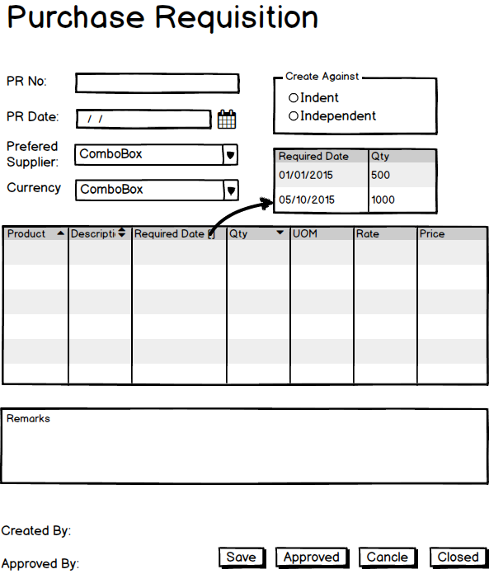

Fig: Purchase Requisition

## Receive Quotation

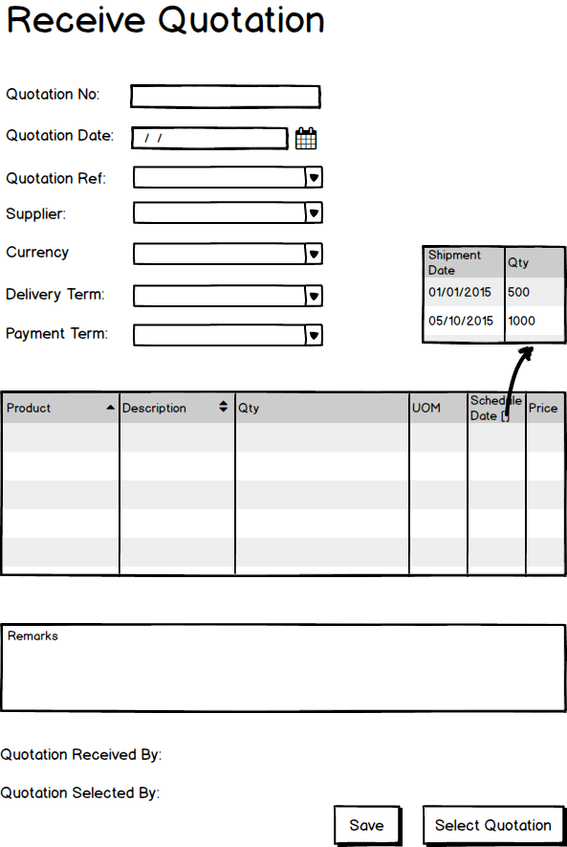

Fig: Receive Quotation

## Purchase Order

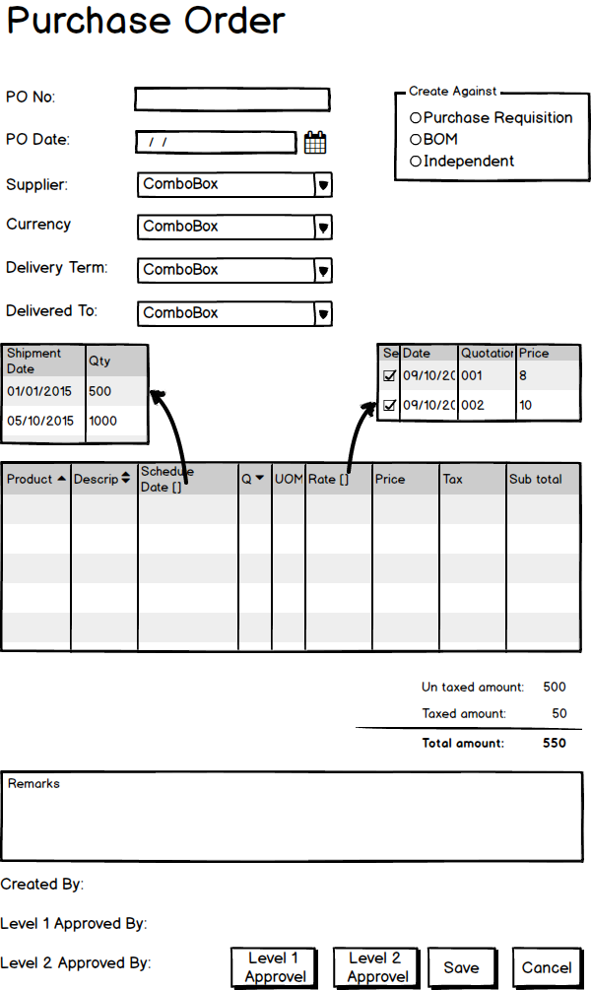

Fig: Purchase Order